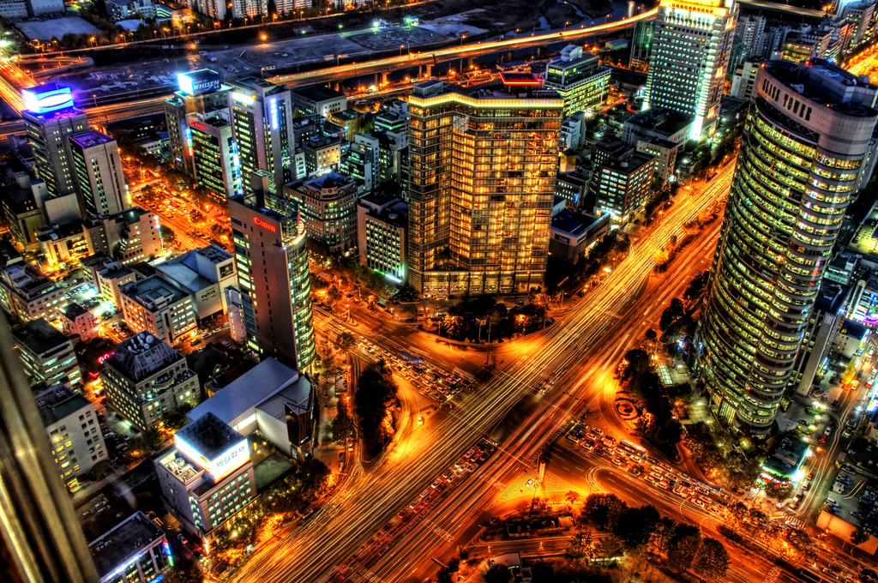

This piece is a real eye catcher. The first thing one notices when looking at it is the intensity of the color. This is clearly a nighttime cityscape taken from the top of a building with a very long shutter speed. In the lower left hand corner part of what appears to be a pillar or a side of a window frame is visible, giving the viewer an idea of how this shot was taken. Another element of the photo that grams the eye is the large void in the middle of the piece. This large intersection makes your eyes push out onto the branching streets and out to the edges of the photo, really drawing your attention into the great detail that was captured. Something that might catch the eye is the lack of varying color. For the most part the light is a mix between yellows and reds making an overall orange tone, but as you work your way out to the edges along the top and right the colors begin to change to a much bluer tone. This really helps drive the piece home.